5. EMR Integration and Data Requirements
The AF-CDSS requires structured access to the following EMR domains. Values and their dates must be retained where specified because the system uses time-dependent rules and research evaluation windows.
Data domain | Required fields | Purpose
Demographics | MRN, patient_id, DOB, calculated age, gender/sex, ethnicity, nationality | Patient identification, subgroup analysis, age-based scoring and dose rules.
Encounter | visit_id, clinic_location, clinic_date, clinician_id, encounter_type, appointment date | Triggering, research timeline, audit trail and follow-up planning.
Diagnosis / PMH | ICD-10, ICD-11, coded diagnosis, problem list, past medical history, and discharge diagnosis, if available | AF identification and comorbidity identification.
ECG | ECG interpretation, coded ECG result, ECG date | AF identification.
Medication | Active medication list, start/stop dates, anticoagulant name, dose, frequency, and indication. | AF identification and anticoagulant-specific rule checks.
Vitals | Latest BP, second latest BP, BP dates, latest body weight and date | Blood pressure review and Cockcroft-Gault calculation.
Laboratory | Serum creatinine and date, creatinine unit, eGFR if available, HbA1c, INR values with dates | Creatinine clearance, diabetes, INR and anticoagulant review.
Hospitalisation | Admission date, discharge date, diagnosis, discharge summary, cause of admission | Three-month post-alert outcome tracking.
Clinician plan | Doctor's plan, medication plan, monitoring plan, next appointment date | Documentation of intended action and follow-up.

5.1 Mandatory Demographic and Encounter Variables
Variable | Requirement | Implementation note
MRN | Mandatory | Hospital medical record number.
Patient ID | Mandatory | Internal system identifier if different from MRN.
DOB | Mandatory | Used to calculate age.
Age | Auto-calculated | Age at encounter date: floor ((encounter_date - DOB) / 365.25).
Gender/sex | Mandatory | Required for the specified scoring and Cockcroft-Gault logic.
Ethnicity | Mandatory if available | Research description and subgroup analysis.
Nationality | Mandatory if available | Research description and subgroup analysis.
Clinic date | Mandatory | Date when the alert/nudge appears.
Next appointment date | Mandatory if documented | Future follow-up date from the appointment module or the clinician's plan.
Doctor's plan | Mandatory if documented | Free-text or structured plan recorded during the encounter.

AF-CArE
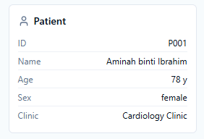
Missing data:
- MRN
- DOB
- Age – Age at encounter date
- Ethinicity
- Nationality
- Clinic Date
- Next appointment date
5.2 Research Data Capture Windows
For each patient who encounters an AF-CDSS alert or nudge, the system must create a research timeline anchored to the first alert/nudge encounter date, defined as index_alert_date.
Window | Time range | Purpose
Pre-alert period | index_alert_date minus 12 months to the day before index_alert_date | Baseline clinical and treatment status before alert/nudge exposure.
Index encounter | On index_alert_date | Clinical data, alert output, clinician action, doctor plan and medication decision.
Post-alert period | Day after index_alert_date to index_alert_date plus 3 months | Follow-up outcomes, medication changes, laboratory/vital changes, admissions and discharge summaries.

Data to capture | Details to store
Medication received | Drug name, dose, frequency, start date, stop date, indication and date of order/change.
HbA1c | Value and result date.
Blood pressure | Systolic/diastolic reading and measurement date.
Creatinine clearance | Calculated ClCr, serum creatinine and weight used, calculation date and source-data dates.
Hospital admission | Admission date, discharge date, admission diagnosis and discharge summary within 3 months after the alert/nudge.
CDSS action | Alert type, options shown, clinician selection, override/defer reason and timestamp.
Appointment and plan | Next appointment date, clinic date, doctor's plan and monitoring plan.

AF-CArE : tiada ruangan utk pre alert index, Index encounter dan post – index period

6. Functional Requirements
6.1 EMR Trigger and Workflow Gating
Trigger rule
IF clinic_location = "Cardiology Clinic or Family Medicine Clinic" AND patient_record_opened = TRUE, THEN run the AF-CDSS screening workflow. Otherwise, do not run the workflow unless additional sites are enabled by the project team.

6.2 Module 1 - Five-Domain AF Identification
Domain | Rule | Accepted values/examples
A. ICD-10 | Any AF-related ICD-10 code in active diagnosis, encounter diagnosis, problem list or PMH. | I48.0, I48.1, I48.2, I48.91, I48.92
B. ICD-11 | Any AF-related ICD-11 code in diagnosis, problem list or PMH. | BC81.3, BC81.31, BC81.32, BC81.3Z
C. ECG | ECG interpretation or coded result indicates AF or atrial flutter. | AF, atrial fibrillation, atrial flutter or approved synonyms
D. Medication | An active anticoagulant is present with an AF indication. | Warfarin, edoxaban, rivaroxaban, dabigatran, apixaban
E. Diagnosis / PMH | Structured or free-text diagnosis/PMH indicates AF or related diagnosis. | Atrial fibrillation, AF, Afib, Atrial Flutter and listed variants

Business rule: if any one of the five domains is positive, patient_status = "AF-positive"; otherwise patient_status = "Not AF" and the workflow terminates immediately. The system must store AF_source as a list because multiple domains may identify the same patient.
Clinician confirmation nudge
Please confirm if this patient was diagnosed with Atrial Fibrillation. If yes, continue the workflow. If No, terminate the AF-CDSS workflow.

6.3 Module 2 - CHA2DS2-VA Workflow
For AF-positive patients, the system must first attempt automatic calculation using structured EMR data. If one or more required elements cannot be reliably retrieved or mapped, the system must display a manual calculator and store the calculation source as manual. Unsupported free text must not be used to guess missing components.
Component | Points | Definition | EMR source
Chronic heart failure | 1 | Symptoms/signs of HF irrespective of LVEF, or asymptomatic LVEF <=40%. | Diagnosis/PMH or structured HF/LV dysfunction flag.
Hypertension | 1 | Resting BP >140/90 mmHg on at least two occasions or current antihypertensive treatment. | Diagnosis/PMH, treatment or structured hypertension flag.
Age >=75 years | 2 | - | Calculated from DOB and encounter date.
Diabetes mellitus | 1 | - | Diagnosis/PMH or structured diabetes flag.
Prior stroke/TIA/thromboembolism | 2 | - | Diagnosis/PMH/problem list.
Vascular disease | 1 | Coronary artery disease or peripheral vascular disease as specified in the source document. | Diagnosis/PMH/problem list.
Age 65-74 years | 1 | - | Calculated from DOB and encounter date.

Condition | System action
All structured elements available | Calculate automatically; display total score and contributing items.
One or more elements unavailable/unmapped | Display the manual calculator and store the source = manual.
CHA2DS2-VA score >=2 | Add alert that anticoagulation is indicated for stroke prevention and current antithrombotic management should be reviewed.
AF-CArE
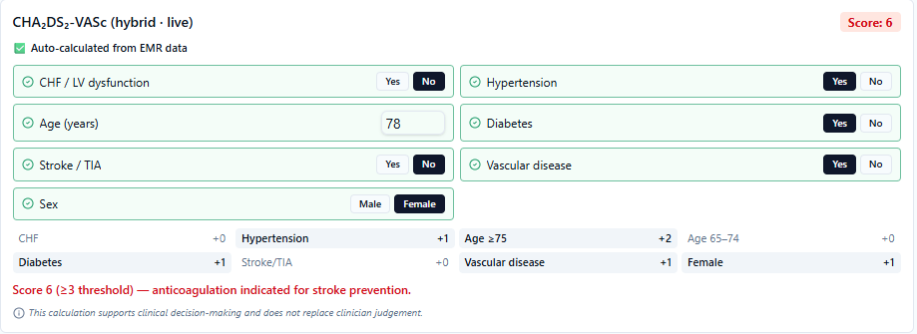
Missing Data:
- Formula kena tukar pd formula yg baru CHA2DS2-VA
- CHA2DS2-VA >2 ; score utk alert berubah (drp 3 kpd 2)
6.4 Module 3 - HAS-BLED Workflow
HAS-BLED must be displayed for AF-positive patients. Unless all required variables are reliably mapped in structured EMR fields, the calculator must require manual clinician input.
HAS-BLED item | Clinical characteristic | Points
Hypertension | Uncontrolled blood pressure / systolic BP >160 mmHg | 1
Abnormal renal/liver function | One point each | 1 or 2
Stroke | Prior stroke | 1
Bleeding | Bleeding history or predisposition | 1
Labile INR | Poor INR control, if available | 1
Elderly | Age >65 years | 1
Drugs/alcohol | Concomitant drugs or excess alcohol use, one point each | 1 or 2

HAS-BLED alert
If HAS-BLED >=3: High bleeding risk. Review modifiable bleeding risk factors. The alert must state clearly that oral anticoagulation is not contraindicated solely because of a high HAS-BLED score.

6.5 Module 4 - Comorbidity Review
6.5.1 Hypertension / Blood Pressure Review
The system must use the two most recent BP readings, must not average the readings, and must display the dates of both readings.
Condition | System action
Two latest readings available and both >140/90 mmHg (BP reading with date) | Blood pressure uncontrolled - review antihypertensive therapy, adherence and follow-up monitoring.
Only one BP reading available | Insufficient BP data. Arrange BP monitoring or update the BP reading.
No BP reading available | No BP data available. Perform or arrange BP monitoring.

AF-CArE

Missing data:
- Date utk blood pressure
- Date utk berat
6.5.2 Diabetes Review Using HbA1c
Condition | System action
Latest HbA1c available (with date) | Display the value and the result date. If HbA1c is above 7%, add an alert to review diabetes therapy/adherence.
No HbA1c data | No recent HbA1c available. Arrange diabetes monitoring.

AF-CArE
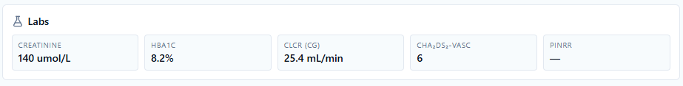
Missing Data:
- Date utk lab result – serum creatinine & HbA1C
- Calculation Clcr – tukar unit tak? If serum creatinine is in micromol/L: Scr_mgdl = Scr_umolL / 88.4.
- Date for calculation CHA2DS2-VA
- INR value dan Date utk PINRR

6.6 Module 5 - Automatic Creatinine Clearance Calculation
Creatinine clearance must be calculated automatically using the Cockcroft-Gault when age, gender/sex, body weight, serum creatinine value, serum creatinine unit, and the required dates are available.
Input | Requirement
Age | Calculated from DOB at clinic encounter date.
Sex | Required for the formula.
Body weight | Use the latest available weight and display its value and date.
Serum creatinine | Use the latest available result and display its value, unit and date.
Unit conversion | If serum creatinine is in micromol/L: Scr_mgdl = Scr_umolL / 88.4.

Cockcroft-Gault formula
Male: ClCr = ((140 - age) x weight_kg) / (72 x Scr_mgdl)
Female: ClCr = 0.85 x ((140 - age) x weight_kg) / (72 x Scr_mgdl)

AF-CArE

Missing Data:
- Date utk lab result – serum creatinine & HbA1C
- Calculation Clcr – tukar unit tak? If serum creatinine is in micromol/L: Scr_mgdl = Scr_umolL / 88.4.
- Date for calculation CHA2DS2-VA
- INR value dan Date utk PINRR

When age, sex, weight or serum creatinine is missing, the system must not calculate ClCr. It must display a reminder that identifies the missing data item.
6.7 Module 6 - Warfarin INR and PINRR Review
Parameter | Specification
Data source | All INR values and INR dates from the EMR.
Lookback period | The last 12 months before and including the index encounter.
Therapeutic range | INR 2.0 to 3.0.
Minimum data | At least 2 INR results (with date)
Method | PINRR = (number of INR readings within range / total number of INR tests) x 100%.
Alert threshold | PINRR <56%.

Condition | Nudge/system response
PINRR <56% | Warfarin control appears suboptimal: fewer than 56% of INR readings are within the therapeutic range. Review adherence, drug and dietary interactions, dosing regimen and INR monitoring frequency.
PINRR >=56% | Warfarin control appears acceptable: at least 56% of INR readings are within the therapeutic range. Continue current therapy and routine INR monitoring, subject to clinical review.
Fewer than 2 INR results | PINRR must be null. Display: Insufficient INR data to calculate PINRR.

When PINRR is calculated, the system must display the PINRR percentage, the number of INR readings used and the date range used.
AF-CArE
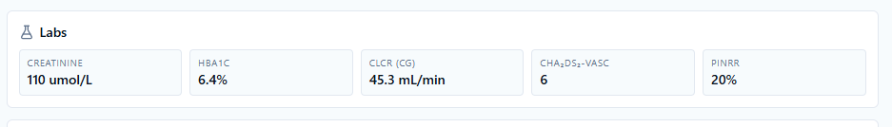
Missing Data:
- Date utk lab result – serum creatinine & HbA1C
- Calculation Clcr – tukar unit tak? If serum creatinine is in micromol/L: Scr_mgdl = Scr_umolL / 88.4.
- Date for calculation CHA2DS2-VA
- INR value dan Date utk PINRR

6.8 Module 7 - Anticoagulant-Specific Rules

This module runs only for AF-positive patients. Before generating a recommendation, the system must identify the current anticoagulant, dose, frequency, indication, order date and the relevant renal, age, weight and laboratory parameters.
Anticoagulant | Rule trigger | Nudge / pop-up alert
Warfarin | Latest INR <2.0 or >3.0 | Latest INR outside therapeutic range. Review dose, adherence, interactions and monitoring frequency.
Warfarin | PINRR <56% | Warfarin control is suboptimal. Review adherence, interactions, monitoring frequency and dose adjustment.
Edoxaban | Clcr < 15 ml/min | Avoid; not recommended because of severe renal impairment. Consider an alternative anticoagulant.
Edoxaban | ClCr 15-50 mL/min | Recommend dose reduction if the current dose is 60 mg once daily, subject to clinical review.
Edoxaban | Body weight <=60 kg | Recommend dose reduction if the current dose is 60 mg once daily, subject to clinical review.
Rivaroxaban | ClCr <15 mL/min | Avoid; not recommended because of severe renal impairment. Consider an alternative anticoagulant.
Rivaroxaban | ClCr 15-49 mL/min | Recommend dose reduction if the current dose is 20 mg once daily, subject to clinical review.
Dabigatran | ClCr <30 mL/min | Avoid or consider an alternative anticoagulant; not recommended because of renal impairment.
Dabigatran | ClCr 30-50 mL/min | Consider dose reduction if the current dose is 150 mg twice daily, subject to clinical review (based on an individual assessment of the thromboembolic risk and the risk of bleeding).
Dabigatran | Age >=80 years | Recommend dose reduction if the current dose is 150 mg twice daily, subject to clinical review.
Dabigatran | Age 75-80 years | Consider dose reduction if the current dose is 150 mg twice daily, subject to clinical review.
Dabigatran | Patient receives verapamil | Consider dose reduction if the current dose is 150 mg twice daily because of a drug interaction, subject to clinical review.
Apixaban | At least 2 of: age >=80 years; body weight <=60 kg; serum creatinine >=133 micromol/L | Recommend dose reduction, subject to clinical review.
Apixaban | ClCr 15-29ml/min | Consider dose reduction if the current dose is 5 mg twice daily, subject to clinical review.
Apixaban | ClCr <15 mL/min | Avoid; not recommended because of severe renal impairment. Consider an alternative anticoagulant.
For apixaban, the system must use a criteria counter. If criteria_count >=2, it must add an alert recommending apixaban dose reduction.
AF-CArE
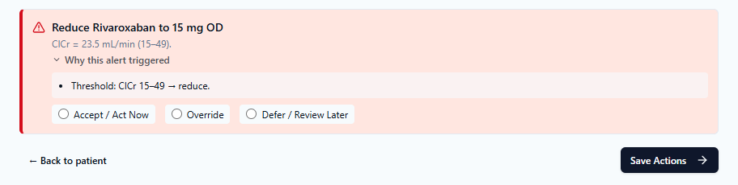
Missing Data:
- Utk dose adjustment / reduce dose – kena ubah ayat mcm dlm table di atas
6.8.1 Define rule precedence
The system should apply the following hierarchy:
Contraindicated → Not recommended → Dose adjustment required → Caution/monitoring → Acceptable
For example, an apixaban patient with CrCl <15 mL/min who also meets two of the three dose-reduction criteria should receive only:
Apixaban is not recommended because CrCl is <15 mL/min. Review and consider an appropriate alternative.
The system should not simultaneously recommend apixaban 2.5 mg twice daily, because the renal restriction takes precedence.

AF-CArE
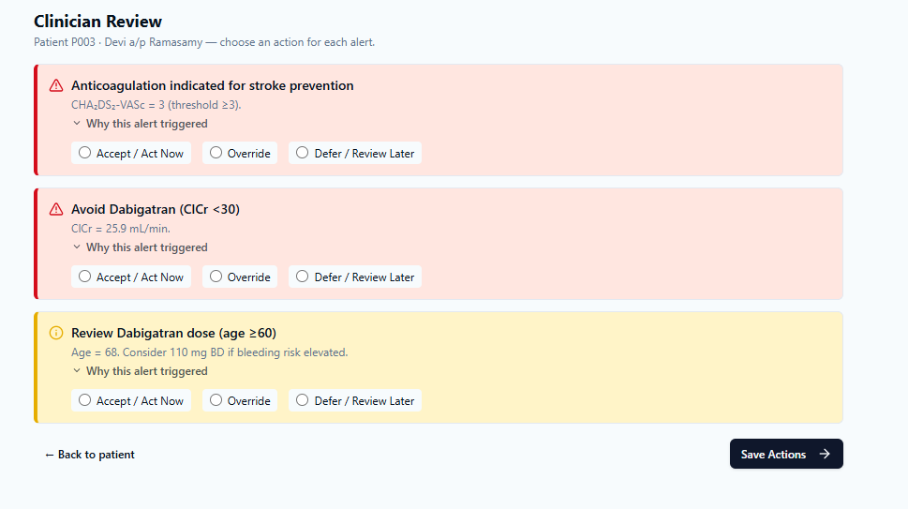
Missing Data:
- If utk ubat tu dh keluar alert utk avoid – x perlu keluar alert review dose.
- Kalu keluar alert avoid – automatic 1 je alert yg keluar.
- Dose adjutment utk Dabigatran – sepatutnya umur lebih 80 thn , tp dlm system umur lebih 60 thn. – kena tgk juga utk ubat-ubat lain syarat utk adjust dose – takut salah.
6.8.2 Override Reasons
Override reason | Description
Dose already appropriate | Current dose or plan is already appropriate.
Clinical judgement | Benefit outweighs risk or a patient-specific decision applies.
Contraindication/intolerance | Contraindication, previous adverse reaction or intolerance.
Renal function issue | Unstable renal function, acute kidney injury or intentional adjustment.
Bleeding risk | High bleeding risk or active/recent bleeding concern.
Adherence issue | Medication adherence problem is identified and being addressed.
Monitoring/titration | Ongoing dose titration, awaiting laboratory results or early follow-up planned.
Patient preference | Patient declined or prefers the current plan after discussion.
Temporary factor | Acute illness, peri-procedure, admission or transient clinical factor.
Other | Free-text reason required.

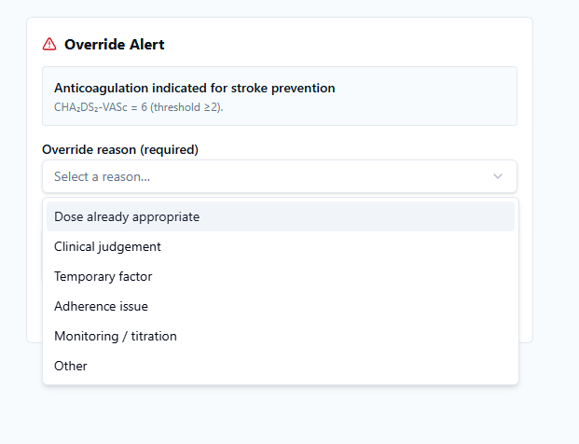
AF-CArE
Missing Data:
- Override reason x cukup mcm dlm list di atas
6.9 Module 8 - Combined Clinical Alert Panel
All triggered alerts, missing-data reminders, monitoring prompts and anticoagulant-specific findings must be aggregated into one panel on the Cardiology Clinic or Family Medicine Clinic encounter/patient profile page.
Panel component | Required content
Panel header | AF CDSS Combined Clinical Alert Panel
Patient summary | MRN, age, gender/sex, ethnicity, nationality, clinic date and AF identification source(s).
Risk scores | CHA2DS2-VA score with automatic/manual source and HAS-BLED score.
Comorbidity findings | Blood pressure and HbA1c findings, including missing-data reminders.
Anticoagulant findings | Current anticoagulant, dose/frequency, ClCr, INR/PINRR for warfarin and drug-specific alerts.
Clinician plan fields | Doctor's plan, monitoring plan and next appointment date.
Action buttons | Accept, Override and Defer.
Documentation | Structured reason fields and optional free-text comment.

AF-CArE
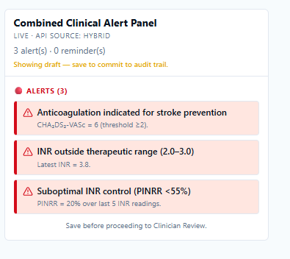
Missing Data:
- Combined Clinical Alert Panel x reflect mcm keperluan di atas
6.10 Clinician Actions
Action | Meaning | System requirement
Accept | Clinician agrees and proceeds with the suggested action. | Open medication review/order or monitoring order screen; log action and timestamp.
Override | Clinician intentionally dismisses the recommendation. | Require a structured reason and optional free text; log the reason, clinician ID, and timestamp.
Defer | Clinician postpones action to a later time or next visit. | Require follow-up plan or next appointment date where possible; log defer reason and timestamp.

7. Missing Data Handling
Missing or unmapped data must not produce an unsupported result. The system response must follow the module-specific rules below.
Module | Insufficient data condition | Required response
Demographics | DOB, sex, MRN or key identity field missing | Do not proceed with age/sex-dependent calculations; display a missing-data reminder.
CHA2DS2-VA | Required structured variables unavailable | Display manual calculator; store source = manual.
HAS-BLED | Inputs unavailable | Display a manual calculator for clinician entry.
ClCr | Age, sex, weight or serum creatinine missing | Do not calculate; identify the missing variable.
BP review | Fewer than 2 readings | Do not trigger the uncontrolled BP rule; add a monitoring reminder.
Diabetes review | No HbA1c | Add a monitoring reminder.
PINRR | Fewer than 2 INR results in the last 12 months | Do not calculate; add a reminder.
Anticoagulant dose rule | Required renal, weight, age or laboratory value missing | Do not generate an invalid dose recommendation; add a missing-data reminder.

8. Audit Trail and Research Export
Every AF-CDSS activation and each clinician response must be logged in a structured table that can be exported for research evaluation.
Log category | Required fields
CDSS activation | patient_id, MRN, visit_id, clinic_location, clinic_date, clinician_id and activation timestamp.
Eligibility | AF-positive status, AF source domain(s), and ICD/ECG/medication/diagnosis evidence.
Data values used | DOB, age, gender, ethnicity, nationality, BP values/dates, HbA1c values/dates, serum creatinine/date, weight/date, ClCr and INR/PINRR with dates.
Scores | CHA2DS2-VA score (date) and automatic/manual source; HAS-BLED score (date).
Rules triggered | Rule name, trigger condition, alert severity and alert text.
Panel display | Whether the combined panel was displayed and the display date/time.
Clinician action | Accept, Override or Defer for each alert.
Reason and plan | Override/defer reason, free-text notes, doctor plan and monitoring plan.
Medication workflow | Whether the medication review/order screen was opened, and whether medication changes were captured.
Follow-up outcomes | Next appointment date and hospitalisation/discharge summary within 3 months after the alert/nudge.

AF-CArE
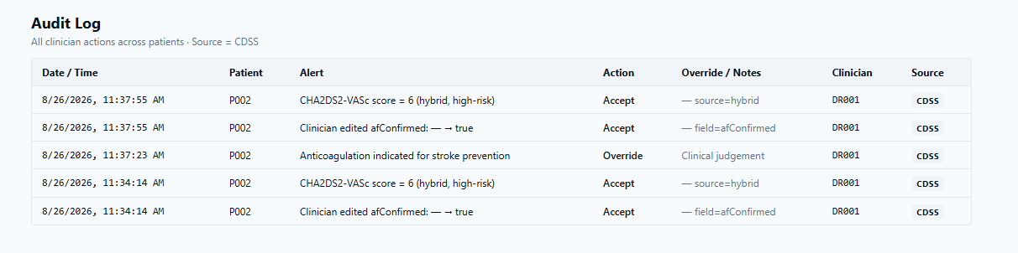
Missing Data:
- Audit trail x reflect mcm keperluan di atas

9. Safety, Governance and Configurability
The CDSS must provide recommendations, alerts and reminders only.
Final clinical decisions remain with the treating clinician.
Critical missing data must prevent invalid dosing recommendations.
Override must always remain available, and the reason must be logged.
All clinical thresholds and medicine dose rules must be validated and approved by the clinical governance team before deployment.
Thresholds, medicine lists and alert text should be revisable in the future without major code changes where possible.

10. ICT Development Deliverables Requested
Deliverable | Expected output
EMR trigger and location gating | Activation logic linked to patient record opening in the specified clinic encounters.
EMR data mapping | Integration of the demographic, encounter, diagnosis/PMH, ECG, medication, vital signs, laboratory, hospitalisation, and clinician-plan fields.
AF identification engine | Five-domain screening, AF_source storage and clinician confirmation workflow.
Risk assessment functions | Automatic/manual CHA2DS2-VA and HAS-BLED workflows.
Clinical calculation functions | Blood pressure and HbA1c review, Cockcroft-Gault ClCr and warfarin PINRR calculation.
Anticoagulant rule engine | Warfarin and specified DOAC rule triggers with structured override reasons.
Combined alert user interface | One panel with findings, plan fields, and Accept/Override/Defer actions.
Audit and research dataset | Structured logging, three-period data capture and exportable research records.
Configurable clinical rules | Ability to revise thresholds, medication lists and alert text without major code changes where possible.
Pre-deployment validation support | Technical testing and clinical governance verification of rules, calculations, alerts and data handling before live use.

11. Proposed Acceptance Criteria
ID | Acceptance criterion
AC-01 | The workflow activates only when a patient record is opened at a Cardiology Clinic or Family Medicine Clinic encounter.
AC-02 | The system classifies a patient as AF-positive when at least one of the five identification domains is positive and records all positive source domains.
AC-03 | A clinician confirmation prompt allows Yes to continue the workflow and No to terminate it.
AC-04 | CHA2DS2-VA is calculated automatically when complete structured data are available; otherwise, a manual calculator is shown, and the source is recorded as manual.
AC-05 | HAS-BLED is displayed for AF-positive patients and supports manual input when variables are not fully mapped.
AC-06 | Blood pressure review uses the two most recent readings without averaging and displays the dates.
AC-07 | HbA1c review displays the value/date and produces the specified alert or missing-data reminder.
AC-08 | Cockcroft-Gault ClCr is calculated only when all required inputs are available, including unit conversion where required.
AC-09 | PINRR uses the 12-month INR window, therapeutic range 2.0-3.0 and a minimum of two INR results (with date)
AC-10 | All anticoagulant-specific rules fire only when their complete trigger data are available and provide an override option.
AC-11 | All triggered findings are displayed in one combined panel with patient summary, scores, findings, plan fields and action buttons.
AC-12 | Accept, Override and Defer actions are logged with clinician ID, reason/plan and timestamps as specified.
AC-13 | Research data are captured for the 12-month pre-alert period, the index encounter, and the 3-month post-alert period.
AC-14 | Each activation, value used, score, rule, panel display, clinician action and follow-up outcome is stored in a structured exportable log.
AC-15 | Missing critical data does not produce an invalid dose recommendation.
AC-16 | Clinical thresholds, medicine rules and alert text are available for clinical governance validation before deployment.

Appendix A - Alert and Reminder Summary
Trigger/condition | Alert or reminder
AF confirmation | Please confirm if this patient was diagnosed with Atrial Fibrillation. Yes: continue. No: terminate workflow.
CHA2DS2-VA >=2 | Anticoagulation is indicated for stroke prevention. Review current antithrombotic management.
CHA2DS2-VA data missing | Display the manual calculator and record the source = manual.
HAS-BLED >=3 | High bleeding risk. Review modifiable bleeding risk factors. Oral anticoagulation is not contraindicated solely because of a high score.
Both latest BP >140/90 mmHg | Blood pressure uncontrolled - review therapy, adherence and follow-up monitoring.
Only one BP | Insufficient BP data. Arrange monitoring or update the reading.
No BP | No BP data available. Perform or arrange monitoring.
HbA1c >7% | Review diabetes therapy/adherence.
No HbA1c | No recent HbA1c available. Arrange diabetes monitoring.
ClCr input missing | Unable to calculate ClCr due to insufficient data; specify the missing item.
PINRR <56% | Warfarin control appears suboptimal. Review adherence, interactions, dosing and INR monitoring.
PINRR >=56% | Warfarin control appears acceptable. Continue current therapy and routine INR monitoring, subject to clinical review.
Fewer than 2 INR results | Insufficient INR data to calculate PINRR.
Latest INR outside 2.0-3.0 | Review warfarin dose, adherence, interactions and monitoring frequency.
Anticoagulant rule triggered | Display the drug-specific recommendation and require structured override reasons when overridden.

Appendix B - Functional Requirements Traceability Matrix
Requirement ID | Area | Requirement summary
FR-01 | Trigger | Run only for the specified clinic_location and patient_record_opened = TRUE.
FR-02 | AF identification | Screen five domains and store AF_source list.
FR-03 | AF confirmation | Display Yes/No confirmation nudge.
FR-04 | Research timeline | Create index_alert_date and three capture windows.
FR-05 | CHA2DS2-VA | Automatic calculation with manual fallback.
FR-06 | HAS-BLED | Display assessment with manual input where required.
FR-07 | BP review | Use two latest readings without averaging; display dates.
FR-08 | HbA1c review | Display the latest value/date and alert or reminder.
FR-09 | ClCr | Automatic Cockcroft-Gault calculation with unit conversion.
FR-10 | PINRR | Calculate from INR values in the prior 12 months with the minimum data rule.
FR-11 | Warfarin rule | Review the latest INR and PINRR.
FR-12 | Edoxaban rule | Use ClCr and body-weight triggers.
FR-13 | Rivaroxaban rule | Use renal-function triggers.
FR-14 | Dabigatran rule | Use renal function, age and verapamil triggers.
FR-15 | Apixaban rule | Use a two-of-three criteria counter.
FR-16 | Combined panel | Aggregate all findings and reminders into a single panel.
FR-17 | Clinician actions | Accept, Override and Defer with required documentation.
FR-18 | Missing data | Prevent invalid calculation/recommendation and show reminders.
FR-19 | Audit log | Store activation, inputs, scores, rules, display and responses.
FR-20 | Export | Provide a structured export for research evaluation.
FR-21 | Governance | Support pre-deployment validation of clinical rules.
FR-22 | Configurability | Allow future revisions without major code changes where possible.

